
Using Your Stepper Motor

Overview:
This tutorial demonstrates how stepper motors work on Arduino boards and how to use them.
Materials:
This project requires an Arduino UNO (or compatible board), a stepper motor, a stepper motor driver board, a small breadboard, an external 5V power source, six female/male jumper wires, and a computer with the Arduino IDE installed with a USB connector for the UNO.
Procedure:
1: Wire together the UNO, stepper motor, stepper motor driver, and 5V power source together according to figure 1. Caution: Do not use the 5V power from the UNO to power the stepper motor, doing so can over-draw current from the board and cause damage
fig.1
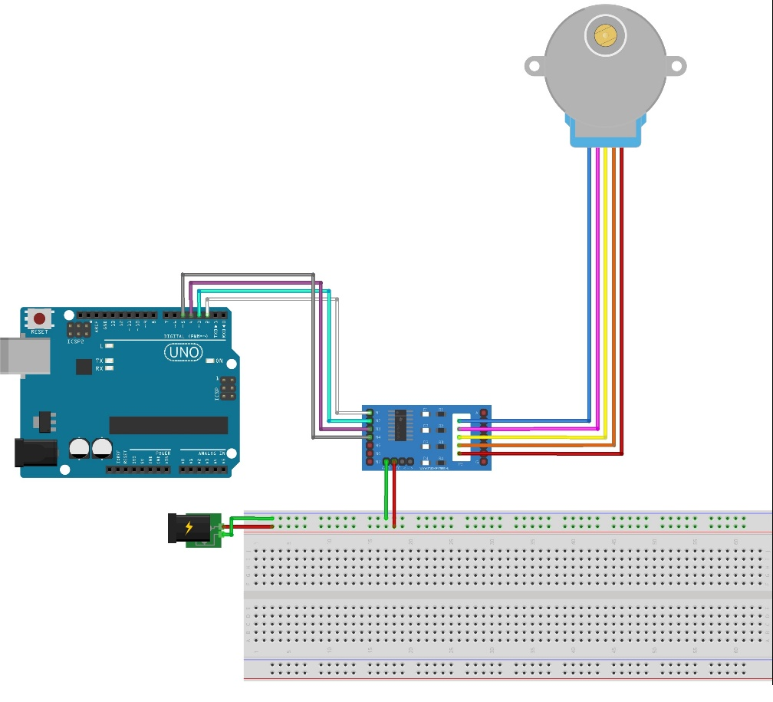

2: Go to www.rabbitrobots.com and download the stepper test program from the “Software” section.
3: Open the downloaded StepperSerial.ino file with the Arduino IDE and upload it to the UNO.
4: Open the serial monitor found under “Tools > Serial Monitor” in the IDE and set the baud to 9600.
5: Set the RPM and steps for the motor to complete using the “setRPM” and “setSteps” commands in the serial monitor
6: Use the “doSteps” command to make the stepper motor run. Caution: The stepper motor becomes hot while running; do not handle the motor while in use.
7: Determine the maximum RPM of the stepper motor by assigning different RPM through the serial monitor
8: Determine how many steps make one full revolution of the stepper motor.
9: See if you can figure out how to make the stepper motor to spin in the opposite direction

Code explanation:
The first section of the code (fig.2) imports the libraries needed to use the stepper motor, define the program’s constants, declare variables used by the program, and declares the actual stepper motor itself. In this section, the lines “#include <Stepper.h>” “Stepper stepperMotor = Stepper(2048, 2, 3, 4, 5);” “int stepperRPM = 20;” and “long steps = 0; deal with using the stepper motor

“#include <Stepper.h>” imports the library of functions for using stepper motors for the program to use. “Stepper stepperMotor = Stepper(2048, 2, 3, 4, 5);” declares the stepper motor itself, its steps per revolution, and the digital pins it will be communicating over. “int stepperRPM = 20;” declares an integer starting at twenty that will store the RPM for the stepper motor. Lastly, “long steps = 0;” declares an integer variable that can hold large numbers to store the number of steps for the stepper motor to complete.
fig. 2
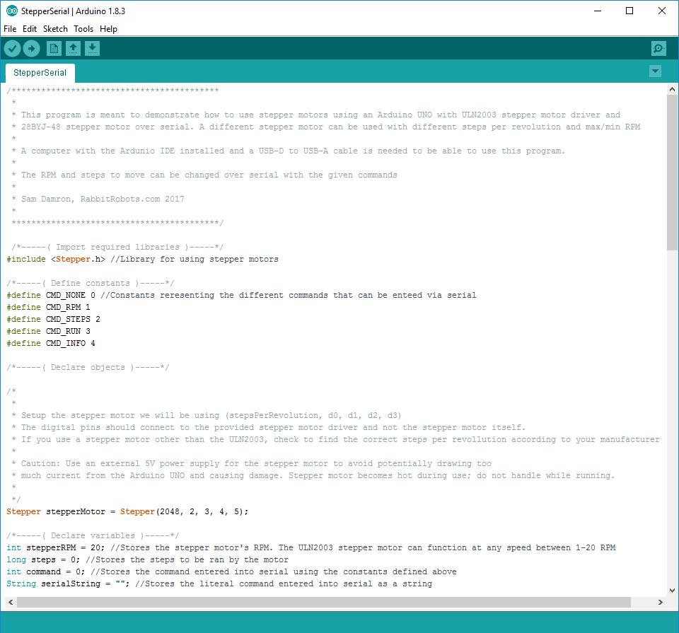

The second section (fig. 3) is the setup() function that runs once when the Arduino starts up. This mostly contains functions for starting the serial connection and providing a user guide to go with it, but it uses the pinMode(pin, mode) function to set up the four digital pins to output mode to use the stepper motor.

fig. 3
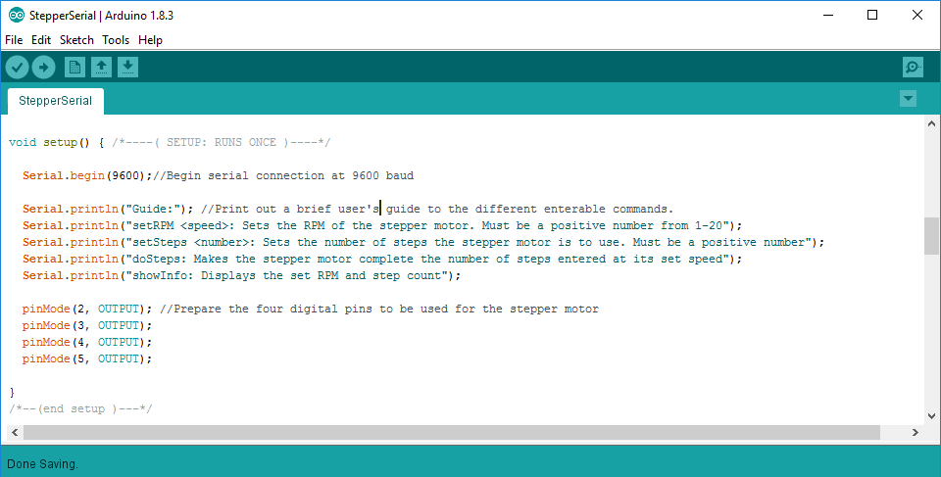

The third section is the loop() function that runs continuously on the UNO once setup()is completed. A majority of this section deals with interpreting the commands given via serial, but there are important functions dealing with the stepper motor as well.
The first half of loop() (fig. 4) deals with getting the command to run from serial and any extra data from that command. The UNO only executes this section of the code when there is data to be read from serial as according to the line “if(Serial.available() > 0){“ at the start of loop(). The first section of else-if statements searches for any commands entered into serial and sets the current command running appropriately.
The second set of else-if statements are for the setSteps and setRPM commands that take extra data, or parameters, from serial. The SetRPM section takes the text after the command, removes any extra empty spaces from it, and try to set stepperRPM to the number written in the text using Serial.parseInt(). However, stepper motors can’t run at negative or zero speeds, so stepperRPM is set to one if it is at zero or below using an if-statement. The setSteps section does the same thing to steps as the setRPM section did with stepperRPM except it allows zero and negative values for steps.

fig. 4
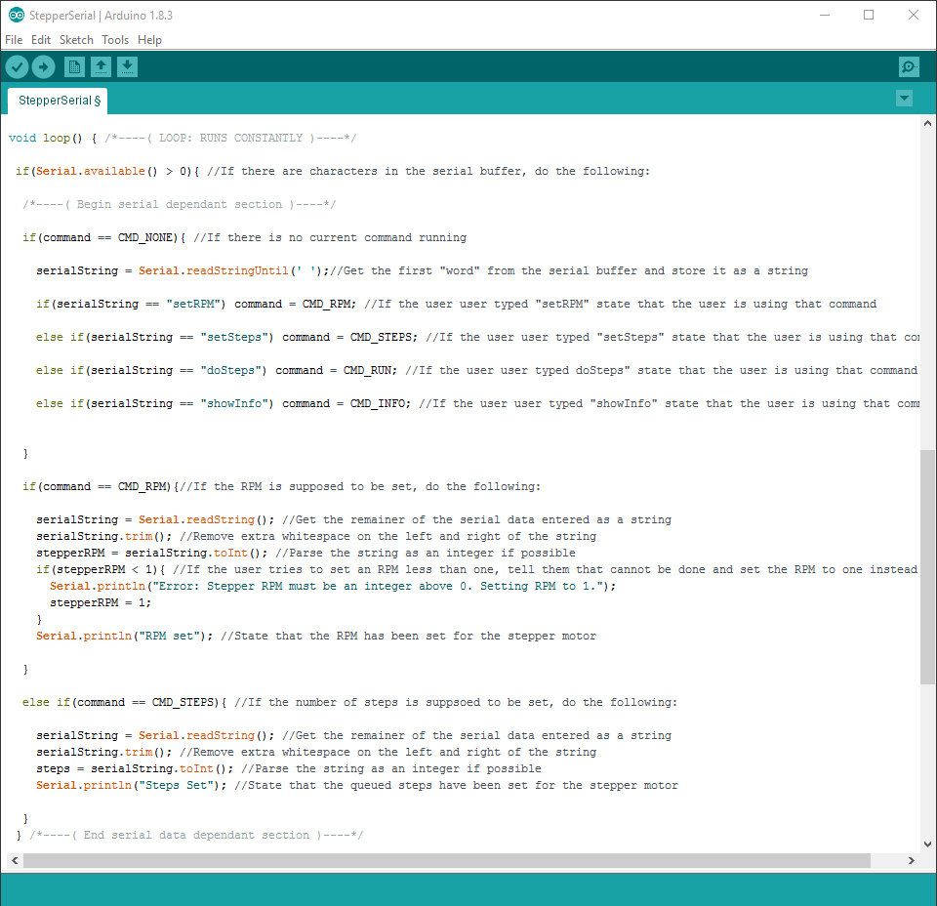
Meanwhile, the second half of loop() (fig.5) does everything that doesn’t need data from serial to run. Much of the code here just displays info with the serial monitor, but the lines “stepperMotor.step(steps);” and “stepperMotor.setSpeed(stepperRPM);” are what make the stepper motor work in the program.
“stepperMotor.step(steps);” is what makes the stepper motor move a number of steps set earlier with the steps variable. This function is special because it stops the entire program until the stepper motor completes its steps. This is why it is important not to run stepper motors constantly in a program; nothing will get done while the motor moves.
“stepperMotor.setSpeed(stepperRPM);” Sets the speed of the stepper motor in RPM according to the number stored in stepperRPM. Unlike the previous function, this does not stop the program, so it can be used constantly in loop().

fig. 5
